***Capstone Project***

**Investment opportunities in Crete, Greece**

1. **Introduction**

Crete is on of the East Mediterranean Islands in Greece, that is as beautiful as it is historic. Crete welcomed in 2016 around 4 million tourists which are the main source of income for the island. 1

The most known city is Heraklion, the capital of Crete, in which you will find the main airport and a large shopping plaza with places like Zara, Bershka and many more known brands in Europe.

Crete is not only known for its beautiful beaches, but also for its great Greek food, historic places to visit and amazing night life. Many investors and developers have opened hotels, restaurants and clubs through the years allowing them a great increase in their revenues due to a yearly incline in tourism.

* 1. **Business Problem**

Due to Covid-19 everywhere in the world there is an uncertainty of whether new businesses could achieve success. Investors are now looking for ways to guarantee a business would be profitable by pinpointing best neighbourhoods in Crete and venues located near those neighbourhoods that could bring in more clients.

Our investment opportunity for this particular business problem is the opening of a Bar in a neighborhood in Crete. The goal of this project is to determine which neighborhoods in Crete are the most popular ones for tourism and local clients.

The question is ultimately: Which neighborhood is the most popular for an investment opportunity such as opening up a Bar and what similar venues are present in this neighborhood?

* 1. **Target Audience**

This analysis’ main objective is to provide information regarding profitable business areas for investors looking to open a Bar in a popular neighborhood in Crete , Greece.

The economy in Crete is mainly sustained by tourism and opening any business there this factor weighs tremendously. Due to Covid-19 the tourism sector is experiencing hardships by millions of Euros lost due to the travel bans in May and June 2020. Tourism in Crete only reopened mid-June, and many are still sceptical on whether travelling is indeed safe.

This analysis will not only focus on previous years’ tourists’ presence and the community that leaves there in order to determine better location for a Bar opening.

1. **Data**

Our objective is to use as much data as possible to provide the most plausible location to open a bar and guarantee at least some amount of success through our analysis.

* 1. **Data Needed**
* Data regarding the number of cities in Greece focusing on Crete
* Longitude and latitude of each city in Crete
* Data regarding airport/s proximity to the city
* Data regarding existing local population
* Data regarding venues nearby the cities and which kind of venues
  1. **Data Sources**
* Cities in Crete , Greece will be obtained from Wikipedia using the link [Greece] <https://en.wikipedia.org/wiki/List_of_cities_and_towns_in_Greece>
* Download latitude and longitude from the Greek site : <https://simplemaps.com/data/gr-cities> ( csv format uploaded on notebook)
* Population Amount per city using the link [Population] <https://en.wikipedia.org/wiki/Demographics_of_Greece>
* Airport list in Crete to determine most preferrable location to open a bar [Airports] <https://en.wikipedia.org/wiki/List_of_airports_in_Crete>
* Foursquare used to find venues near specifically for the main cities in Crete (using bars, cafe, hotels and restaurants)

1. **Methodology**

We will be using methods such as matplotlib, k-means, one-hot encoding to analyze our data.

* 1. **Matplotlib**

After creating a data frame containing all the information needed such as population, city and coordinates we will perform:

* Bar graph showing Population versus City name
* Horizontal Bar graph City versus Bar types
* Horizontal Bar graph City versus Restaurant types
  1. **Four Square Data pulled from the site for venues**

Using unique client code and ID to access venues nearby the cities and analyze which ones are more impactful on the opening of a bar ( in our case we took other bars and restaurants)

* 1. **One-hot encoding**

Used to determine similarity of the data used and whether it will be useful for our further analysis

* 1. **K-means**

Group data in 2 clusters (0 and 1) based on similarities and using the top 5 venues

1. **Results**

**Tables**

Table 1. Compiled table from 3 Wikipedia sources listed in Data section (Airport, Greek cities , Population) (sample of 5 rows)

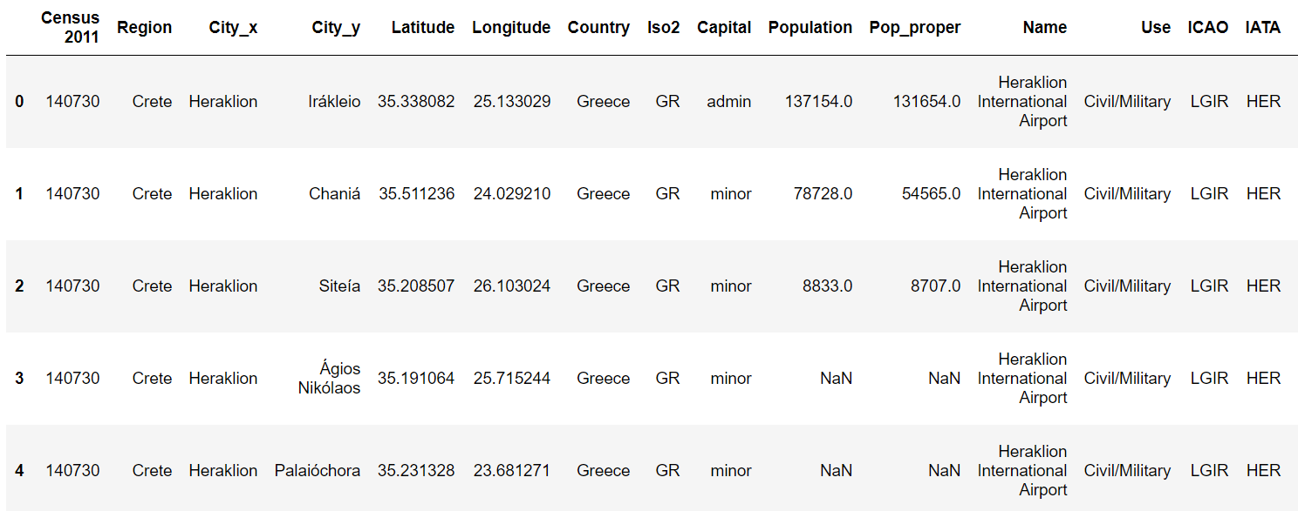

Crete data is not as large as you would expect considering the island’s size and population, but Wikipedia did have information regarding main cities. To increase our data to analyze we include the airports and population as a factor in opening a Bar in one of the cities.

Table 2. Venues obtained through Four Square near Crete’s cities (sample of 5 rows)

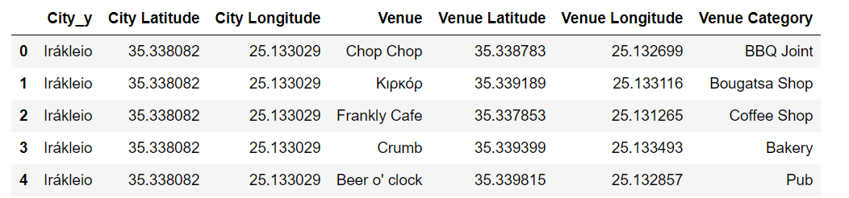

Table 3. Top 5 most common venues near Crete’s cities (sample of 5 rows)

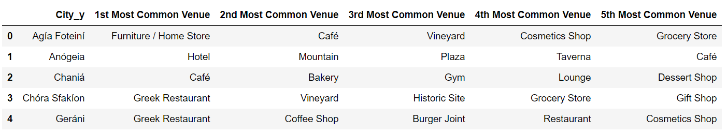

Table 2 and 3 show venues taken from FourSquare site. Commonly observed that restaurants , cafes and hotels are much more dominant than others which indicates tourism does have a great impact on business structure in Crete.

**Figures**

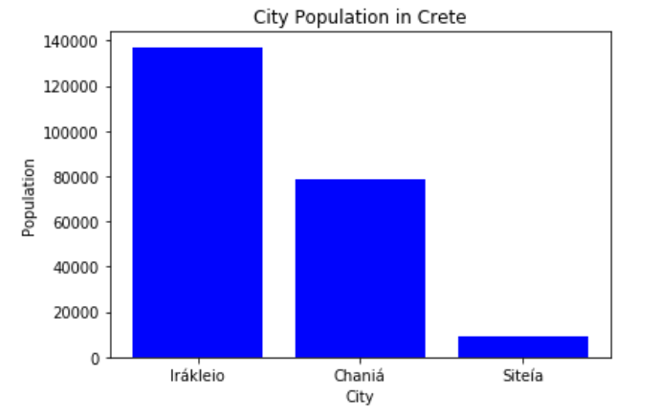

Figure 1. Bar Graph depicting City versus Population (major cities showing only)

Due to Greek being a non-latin language the way cities are written (check Table 1. Column city_x and city_y) differ depending on the data source we retrieved. In this case the highest population is in Irakleio or commonly known as Heraklion ( capital city of Crete)

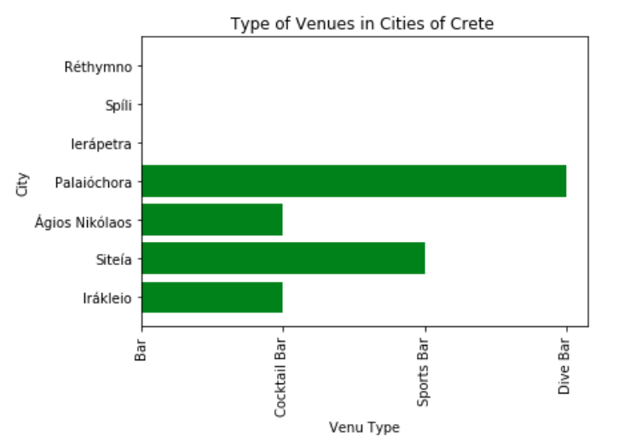

Figure 2. Horizontal Bar Graph depicting cities and the most common venues specific to Bar types

Crete Analysis

Figure 3. Venue type in cities of Crete grouped by Restaurant type

The bar graphs Figure 1 and 2 help us visualize the cities were bars and restaurants are in highest numbers respectively.

1. **Discussion**

The most impactful information we received through this analysis is that Crete data is not as extensive as we originally believed it would be. The number of cities that had no to very little information was large considering we are considering one of the biggest islands in Greece.

However, the lack of information could be caused by the fact that most statistical knowledge of Crete cities and postal codes were in Greek and translation was not viable in terms of data we could use and combine with other lists derived from Wikipedia.

* 1. **Discovery**

When we take a closer look at the tables above (Results section) we deduct the following information:

* Cities in the tables (i.e. Result section) are labeled ‘City_x’ and ‘City_y’ where x was the English way of writing the cities name and y is the modern Geek spelling.

Table 1 is showing ‘City_x’ as Heraklion for many rows meanwhile ‘City_y’ in every row is different. The reason behind this discrepancy is many lists consider Heraklion a city, but Greek people consider it a region as well, which is made up of other cities. This is the reason why we took ‘City_y’ data when we did our analysis as it is more accurate description of a city in Crete.

* Population data is only available in few cities as seen in Table 1.

The population data is based on Census 2011 (which is the population count done in the year 2011). Although the count is not recent, what we want to determine is the trend and the difference in local population in these cities. We can deduct that the city with the highest population would provide a more profitable business opportunity all year around due to larger clientele.

When constructing the bar graph of population Figure 1, we see 3 main cities in blue with the lowest population count of 8833. From this plot we can deduce that ‘Irakleio’ also known as ‘Heraklion’ is the city with highest population and thus a very good starting point for opening a business.

* Figure 2 and 3 depict Bar and Restaurant Venues near cities focusing on most common one

Business opportunities do not solely depend on population but more commonly on tourist presence in the cities. We have used FourSquare to not only see the type of venues, but isolate based on restaurants and bars in the cities. A city that is filled with tourists will have a larger presence of restaurants, hotels and bars.

Considering AirBNB has become widly popular as a hotel substitution for few years now, this analysis focuses on restaurants and bars in order to determine more accurately the most profitable city.

* Figure 2 and 3 help us determine which locations we would see most fit to open a Bar

Cities that have a lower number of Bars but a larger number of restaurants focusing on ‘Greek’, ‘Seafood’ and ‘Fast food’ restaurants are the prime targets of this analysis. The reason these 3 types of restaurants were picked is directly related to their proximity to the common tourist attraction sites as per ‘Tourism in Greece’ (<https://en.wikipedia.org/wiki/Tourism_in_Greece> ) site.

We see in Figure 2 that in ‘Agios Nikolaos’ the common type of Bars is a ‘cocktail bar’ which would not pose a great competition to our Bar ( since we will go with a general type of bar which also serves finger food ) . However, in Figure 3 no restaurant types that interest us are listed for this city which causes us to exclude it from our final choice.

Next city in Figure 2 that could be a potential pick for a bar is ‘Irakleio’ or Heraklion which also has mainly cocktail bars. In Figure 3 this city is commonly known for having Tapas restaurants which serve Spanish type of dishes focusing on Seafood which even though it is not labeled by Foursquare as the type of venue we were focusing on it directly relates to it.

1. **Conclusion**

Our business problem is which city would be best to open a Bar in Crete where profitability would be focusing not only on tourism but also local population. We have gathered data lists from Wikipedia and information in Greek sources to determine validity of city names, population and airport data.

From this analysis using k-means and clustering we observed that focusing on lower number of bars in the area and larger number of restaurants we were able to isolate one city with a higher chance of success for this business venture.

Heraklion , known as ‘ Irakleio’ in Creteis the best city to open a Bar due to the fact that it has the largest local population according to our data and has its own airport . It also provides a limited amount of Bar types focusing on cocktail bars which do not serve any type of food. The restaurants in the area are commonly seafood which would differentiate our bar’s food types since it will mainly be finger food. We chose Heraklion also because the number of its fast food restaurants is not as high as in other cities which would allow tourists to visit a Bar as an alternative to fast food.